Mars China –
Forecast Extract & Loading Process

Functional Specification



A DIVISION OF EFFEM FOODS PTY. LTD. A.C.N. 008 454 313
PART OF MARS INCORPORATED

PO BOX 153, WODONGA, VICTORIA, 3689
TELEPHONE +61 260 551 122
FACSIMILE +61 260 562 169

Table of Contents

1. Table of Contents i
2. Revision History ii
Athena For Sales Forecast Loading 3
1. General Description 3
1.1. Overview 3
1.2. User Characteristics 3
1.3. Related System Information 4
1.4. General Constraints 5
2. Functional Requirements 6
2.1. Apollo Demand Generated Domestic Quantity Forecast 6
2.2. Apollo Supply Manipulated Domestic Quantity Forecast 6
2.2.1. Introduction 6
2.2.2. Inputs 6
2.2.3. Processing 6
2.2.4. Outputs 6
2.3. Apollo Supply Generated Affiliate Quantity Forecast 6
2.4. Extract of Domestic and Affiliate quantity forecast from Apollo 7
2.4.1. Introduction 7
2.4.2. Inputs 7
2.4.3. Processing 7
2.4.4. Outputs 7
2.5. Loading of Pricing data from Atlas to China Forecast Database System 8
2.5.1. Introduction 8
2.5.2. Inputs 13
2.5.3. Processing 13
2.5.4. Outputs 13
2.6. Calculation of GSV forecast in China Forecast Database System 13
2.6.1. Introduction 13
2.6.2. Inputs 13
2.6.3. Processing 13
2.6.4. Outputs 13
2.7. Extract of GSV/Qty Forecast from China Forecast Database System 13
2.7.1. Introduction 14
2.7.2. Inputs 14
2.7.3. Processing 14
2.7.4. Outputs 17
2.8. Loading of forecast data file to BW 17
2.8.1. Introduction 17
2.8.2. Inputs 17
2.8.3. Processing 17
2.8.4. Outputs 17
3. Interface Requirements 18
3.1. User Interfaces 18
3.1.1. China Forecast Database System Forecast Extract Screen 18
3.1.2. BW Web Page for Loading Sales Forecast Data 18
3.2. System Interfaces 18
3.2.1. Apollo Demand to Apollo Supply 18
3.2.2. Atlas Pricing data load into China Forecast Database System 18

Revision History
This table advises the reader how this version of the document varies from any previous release.
The Revision # field shown here is the unique identifier for the release of this document.
The Date field details the date on which it was released.
The Section Number field details the section number that contains the amendment(s).
The Amendment Detail field list the details of the amendment(s).

Revision # | Date | Section Number | Amendment Detail
0A | 21 Jan 2008 |  | First release of this document

Athena For Sales Forecast Loading

General Description

Overview
With the advent of Atlas in Mars China, the current process of calculating GSV forecast will be redundant. Therefore, this document will describe functionally that is proposed to extract forecast data from Apollo, calculate GSV forecast and then load forecast data into the BW Sales model for reporting.

User Characteristics
The expected users of this functionality are described as follows:
User | User Interaction
Apollo Planner | Responsible for:  - Generating forecast using Apollo.  - Loading the forecast data file into BW using the Web page interface.
S&F Pricing Administrator | Responsible for the maintenance of pricing information in Atlas which will ultimately interfaced to the forecast database for the purpose of forecast GSV calculation.
Sales Associate (Report User) | User of Sales reports which contain forecast and actuals information.

Related System Information
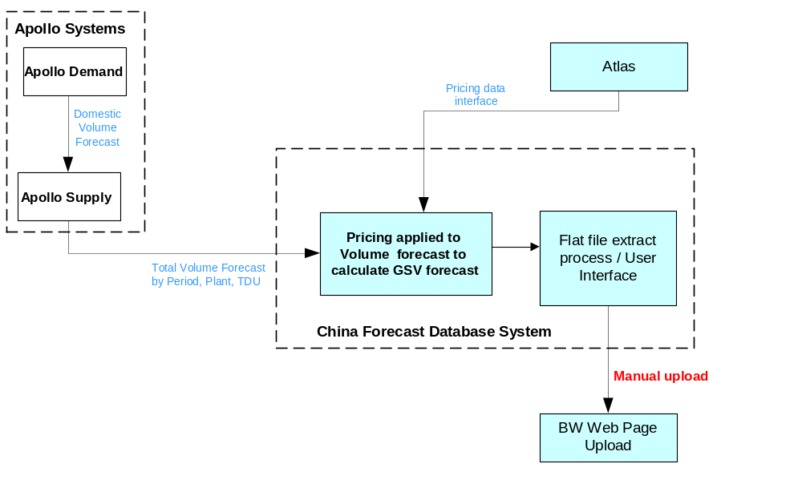The following diagram illustrates the various systems and relationships in this proposed functionality.
Figure 1 - Related Systems used to generate GSV forecast data
The related systems and brief functional responsibilities are as follows:
System | Functional Responsibility
Apollo Demand | Generates the Domestic sales quantity forecast at the ZREP level and passes that data to Apollo Supply using an existing Apollo internal data interface.
Apollo Supply | - Receives the Domestic quantity forecast from Apollo Demand and breaks that ZREP forecast down into TDU level forecast using internally maintained mapping.  - Makes the above converted Domestic quantity forecast at TDU available to the user via an Apollo “FE” screen.  - Generates Affiliate quantity forecast (Planned Shipments) at TDU level.  - Sends the affiliate and domestic forecast to the China Forecast Database system.
Atlas | All pricing data will be maintained in Atlas.
China Forecast Database System | - Receives that Affiliate/Domestic Qty forecast from Apollo Supply and using Atlas supplied pricing data, calculates the forecast GSV.  - Generates the Qty and GSV Forecast in a pre-defined flat file for manual loading into BW.
BW | - Receive the GSV/quantity based forecast data via Web page manual load.  - Make the forecast data available for reporting in the existing Athena for Sales model.

General Constraints
Known constraints at this time are as follows:
- This functionality is required in time for Atlas go live in P6, 2008. Therefore, delivery into production environments must be in or before P5, 2008.
- No changes to existing BW Functionality will be possible prior to go live. This is due to transport slot constraints.

Functional Requirements
The functional requirements that will be defined here are as follows:
- Generation of Apollo Demand Domestic quantity forecast.
- Apollo Supply conversion of Apollo Demand Domestic quantity forecast from ZREP to TDU level.
- Generation of Apollo Supply Affiliate quantity forecast.
- Extract of Domestic and Affiliate quantity forecast from Apollo.
- Loading of Pricing data from Atlas to China Forecast Database System
- Calculation of GSV forecast in China Forecast Database System.
- Extract of GSV/Qty Forecast from China Forecast Database System.
- Loading of forecast data file to BW

Apollo Demand Generated Domestic Quantity Forecast
Apollo Demand will generate a quantity forecast for Domestic sales at the ZREP level.
The output of this process will be to interface the Domestic quantity forecast data to Apollo Supply.
This is an existing interface and it is not the scope of this document to define how this interface functions.

Apollo Supply Manipulated Domestic Quantity Forecast

Introduction
Apollo takes the Apollo Demand forecast and manipulates from a ZREP level forecast into a TDU level forecast. This forecast will then be made available to users as a manually extracted data file.
Note: it is not the scope of this document to define the process by which this forecast is converted from ZREP level to TDU level. That is existing Apollo functionality.

Inputs
Inputs are as follows:
- The Apollo Demand quantity based forecast at the ZREP level.
- ZREP to TDU conversion mapping.

Processing
Apollo Demand forecast is split from ZREP to TDU level quantity forecast.

Outputs
The Apollo Demand quantity forecast is available in Apollo Supply at the TDU level.

Apollo Supply Generated Affiliate Quantity Forecast
The Affiliate forecast data is stored in Apollo Supply. This data is available for extraction from Apollo Supply.

Extract of Domestic and Affiliate quantity forecast from Apollo

Introduction
This functionality is responsible for extraction of the Domestic and Affiliate quantity forecast data and sending to the China Forecast Database System.

Inputs
The Domestic and Affiliate Forecast Data as manipulated by Apollo Supply.

Processing

<<<< TO BE CONFIRMED ….. ASSUMED THAT THE EXISTING EXTRACT PROCESS FROM APOLLO TO CHINA DATAWAREHOUSE WILL BE RETAINED>>>

Outputs
<<<< TO BE CONFIRMED >>>>>

Loading of Pricing data from Atlas to China Forecast Database System

Introduction

Background on Pricing Data in Atlas
Pricing information is required in the China Forecast Database so that the quantity forecast can be converted to GSV forecast. This pricing information currently exists in LADS and it is therefore proposed to utilise the same source and extract process for pricing data.
The pricing in SAP is maintained for a traded unit or representative item at one or more of the different levels below:
- Sales Organisation
- Distribution Channel
- Account Assignment Group
- Customer Division
- Ship-to Customer
- Bill-to Customer
- Sold-to Company Code
- Invoicing Party
- Destination Warehouse
Pricing is maintained in SAP using pricing conditions and access sequences (e.g. sales organisation/distribution channel/material).
At what level (access sequence) the price is maintained in SAP and which condition is to be used depends on many factors, some of which are:
- Is the forecast for the domestic or affiliate market?
- Has the affiliate implemented APOLLO Supply?
- Has the affiliate implemented SAP?
- Is the affiliate in this region?
Note that pricing conditions and access sequences used to calculate the forecast GSV can only be at a level of detail which can be matched to the level of detail in the forecast.
There are two separate transactions in SAP to display pricing:
- VK13 (Display Condition) for domestic, non-regional ATLAS affiliates and regional affiliates not currently using SAP
- MEK3 (Display Condition (Purchasing)) for affiliates in the region which have SAP installed
Example of displaying pricing
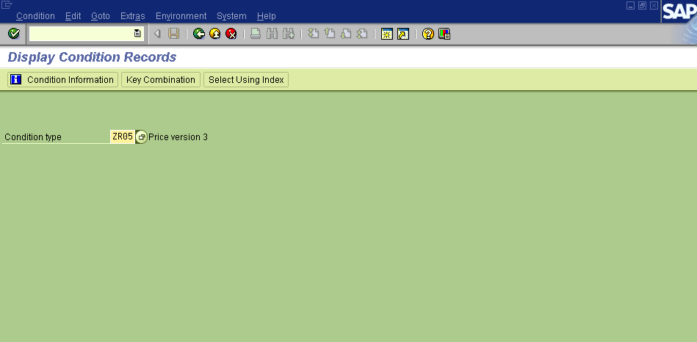
Logon to SAP and type in the transaction code VK13
The following screen is displayed:

Enter the pricing condition required and press Enter to see a list of valid access sequences for this pricing condition:
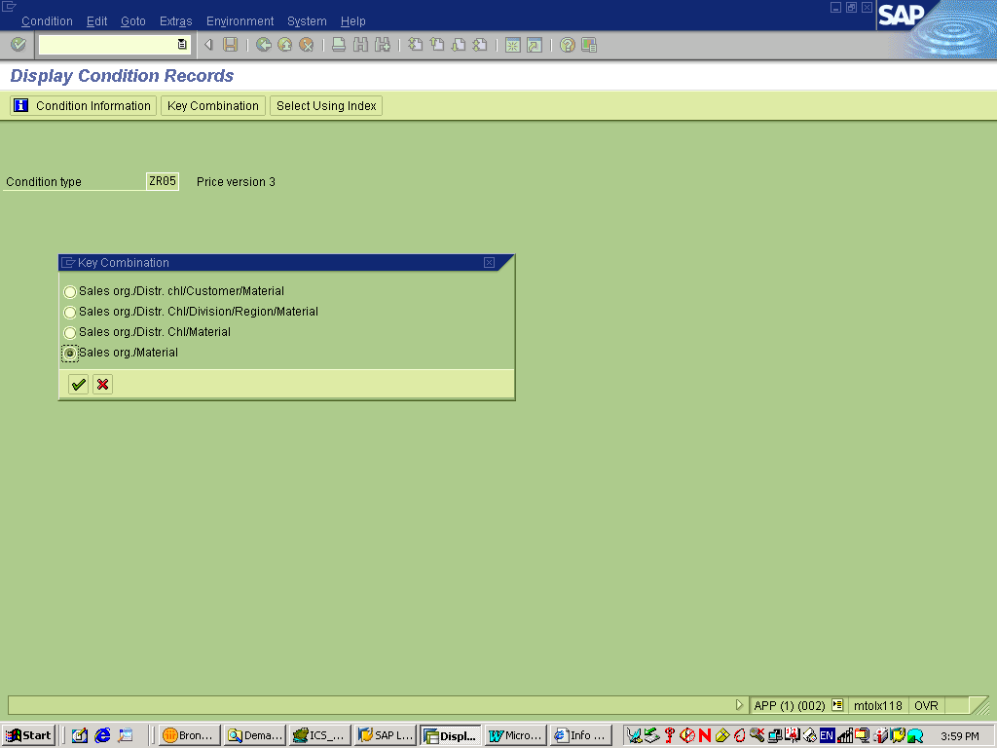
Select the key combination (access sequence) to be reviewed then click on the “tick” (“check”) button to display the parameter selection screen:
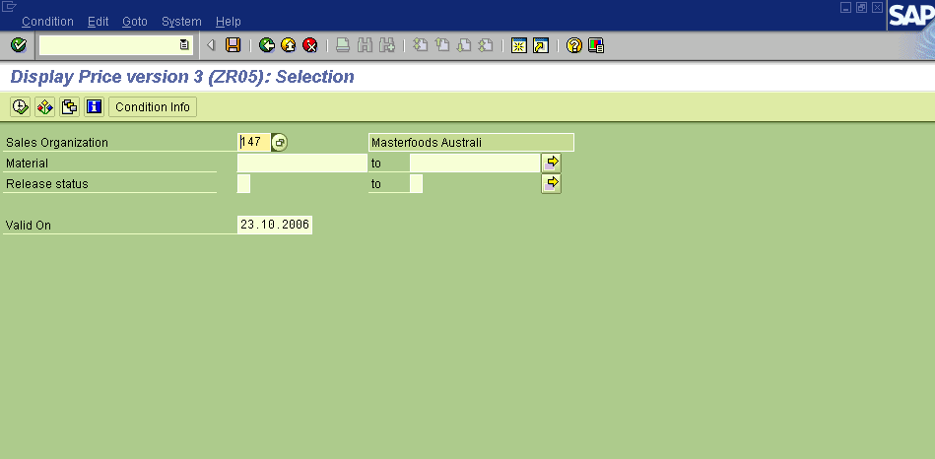
Type in or select the parameters as required and press Enter to validate and then click on the “tick” (“check”) button to display the prices for the pricing condition, access sequence and parameters selected:
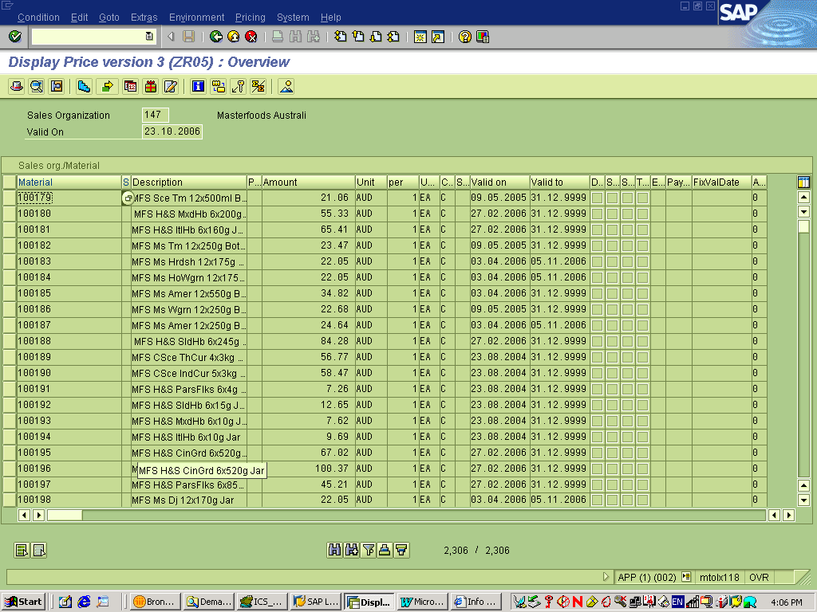
To view all the access sequences used by a specific pricing condition enter the pricing condition on the first screen and click on
and enter parameters as required on the following screen:
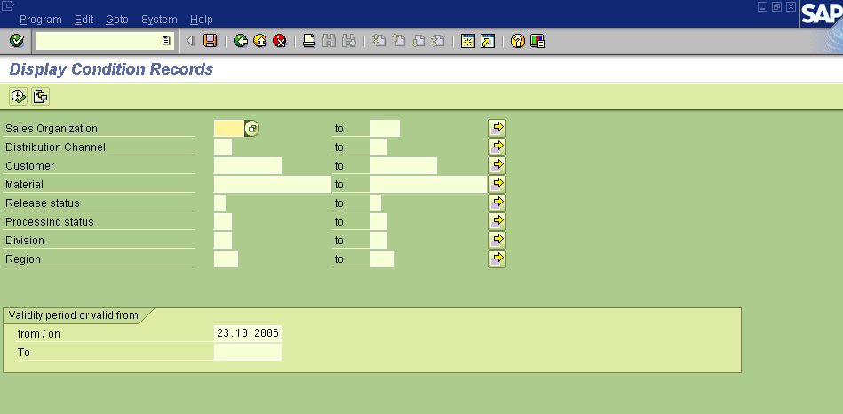
If no parameters are entered and the user clicks on the “execute” button and a list of the key combinations, which have prices, is displayed.
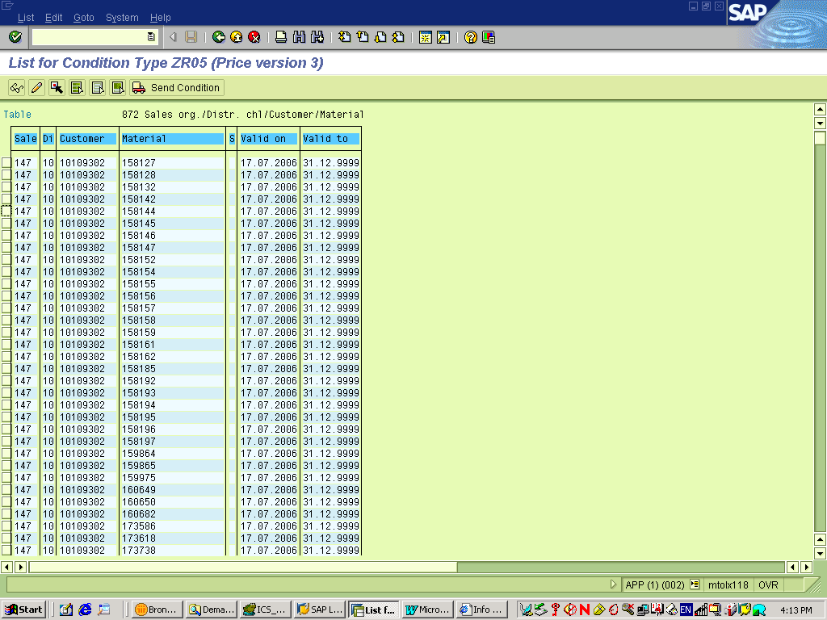
PO pricing using transaction MEK3 can be displayed using similar screens.

Pricing Data Use by Mars China
Following are (still) rough notes taken to determine pricing conditions used by Mars China in Atlas:

GSV = Quantity * Price
GSV
- Domestic (A)
  - VK11
  - By Material
- Affiliate
  - A2A
    - MEK1
    - By Customer/ By Material
    - ZV01
  - A2NA
    - VK11
    - ZV01
To Note:
- GSV Operating Plan will remain the same
- GSV Forecast is time bound
  - What is the lowest time denomination?

Questions
- What are the dimensions price is defined by ?
  - PR00
    - Sales Org/ Material
    - Sales Org/ Distr Chl/ Material/ Price List
    - Price List Category/ Currency/ Material with release Status
    - Sales Org/ Distr Chl/ Price List/ Currency/ Material
- What dimensions are used by Mars China
    - Sales Org/ Material
- Is there any concept of discounting?
  - Discounting is applied to an invoice with the relevant discount codes. Discounts are not included in GSV calculations.
- GSV = Quantity * Price
- Time phase?
- Does list price change throughout the year?
  - Rarely. List prices changing are usually done as projects within the business
- List Price is required calculate GSV
- GSV Excludes tax
- Demand planning does not do GSV forecasts of Affiliate Sales
- GSV forecast is the same for Domestic as Affiliate
- Is Mars China using Plan Pricing?
Need to document that we are only using list price & not plan price.

Inputs
<<< TO BE COMPLETED BY LINDEN (LADS PRICING EXTRACT PROCESS) >>>

Processing
<<< TO BE COMPLETED BY LINDEN (LADS PRICING EXTRACT PROCESS) >>>
Consideration would need to be given to the event that a price cannot be found for a given forecast record. Should it error or be ignored?

Outputs
<<< TO BE COMPLETED BY LINDEN (LADS PRICING EXTRACT PROCESS) >>>

Calculation of GSV forecast in China Forecast Database System

Introduction
<<< TO BE COMPLETED BY LINDEN >>>

Inputs
<<< TO BE COMPLETED BY LINDEN >>>

Processing
<<< TO BE COMPLETED BY LINDEN >>>

Outputs
<<< TO BE COMPLETED BY LINDEN >>>

Extract of GSV/Qty Forecast from China Forecast Database System

Questions:
- Can the users only nominate a Forecast Version that exists or can they define a forecast version for a future period?
- Do they require reporting from the Forecast database solution, or is analysis performed within Apollo for determination of which forecast version is to be officially published?
- What are the process timings?
- Demonstrate current functionality of version controlling/definition.
- Approximate size of extract (i.e. how many records)?

Introduction
This process will be responsible for allowing the user to extract forecast data from the China Forecast Database system ready for manual loading into BW.

Inputs
The input into this process are as follows:
- Quantity and calculated GSV forecast data in the China Forecast Database system (as defined under Calculation of GSV forecast in China Forecast Database System 13).
- User initiation of the extract process via User Interface.

Processing
Processing is defined under the following categories:
- User initiated manual extract.
- Forecast versioning structure.
- File format

User initiated manual extract.
The extract is to be initiated by a user via a user interface as described under China Forecast Database System Forecast Extract Screen 18.

Forecast versioning structure.
It is a requirement to be able to retain versions of forecasts so that forecast version comparison reporting is possible. In addition to this, we also need to be able to determine what the current officially published forecast is (independent of historical versions). To do this, part of the key of a forecast file will be a version value.
The implication of the above is that we will have two different methods of versioning forecasts. They are as follows:
- Period version of Forecast.
- Current Official Forecast version.

Period Version of Forecast
This method will allow us to retain full versions of forecasts as they are published. This is useful for historical forecast and comparison reporting.
Each forecast will have a period value defining the period for which the forecast should start to be used.
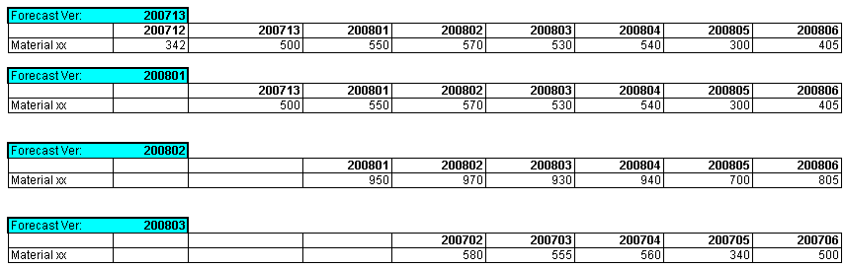
The following examples illustrate how forecasts are to be versioned:
Figure 2 - Forecast Version Examples
The following should be noted regarding forecast versioning:
- The period that a report is published is called the “Casting Period.”
- Typically, the forecast is published in week three of a period, however, that may not hold true in all cases.
- The name of the forecast version is to be the immediately following period from the casting period.
- The forecast data file will contain forecast records for the period equal to the Casting Period.

“Official” Version of Forecast
In addition to a forecast attaining a Forecast Version as defined above, there is also the need to define which is the official version of the forecast that the business is to use at any point in time.
To achieve this, it is proposed to also generate a series of forecast records with the Forecast Version equal to “OFFICIAL”. This will allow to business to know that this version is always current.
In addition to this, the period equal to the Casting Period of a new forecast should never to overwritten. For the Official forecast, only the period after the current period (and beyond) is to be updated with the new forecast values.

Examples of Official and Named Forecast Versions
The following examples illustrate the difference between the named Forecast and “Official” Forecast versions.

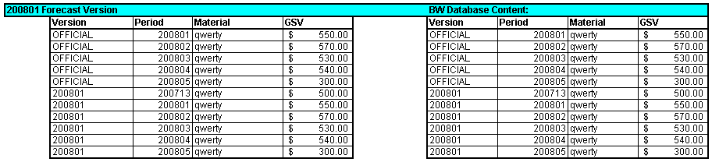
Example 1: Loading of Forecast version “200801”
Figure 3 - Example data for forecast version 200801
This example shows that in the casting period of 200713 the forecast version “200801” data file is created which contains the version equal to “200801”. Note that this version contains data starting at 200713.
In addition to this, the file contains updated values for the “OFFICIAL” version. The data for this version is a copy of the 200701 version. However, this version starts at the period subsequent to the Casting Period. Therefore, this version starts at period 200801.
Note that the Official version does not contain a forecast value for the period equal to the Casting Period.
The result of this is that when the data file is loaded into BW, it (BW) will contain the data as per the contents of the data file (as shown on the right hand side of the example above).

Example 2: Loading of Forecast version “200802”
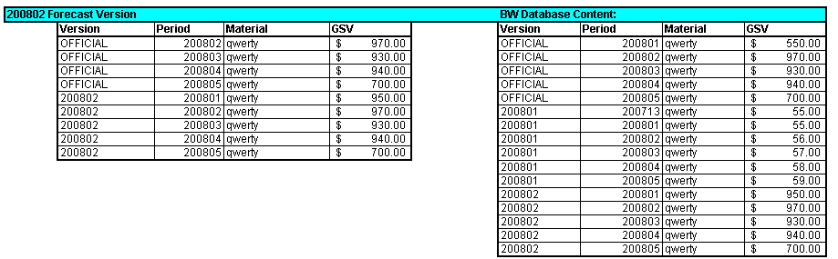
This example shows the result of loading the next version of forecast: Version “200802” which is created in the Casting Period 200801.
Note again that the file contains version “200802” and the “OFFICIAL” version. OFFICIAL is a copy of the 200802 version, but excluding the period equal to the Casting Period (i.e. 200801).
The effect of this can be seen once the data is loaded into BW. Firstly, the new version 200802 is loaded into BW as a new set of records. However, the OFFICIAL version of the forecast replaces the previously loaded version only for those periods that are in the new file.
Note that the OFFICIAL version’s period 200801 record is not replaced by the new data. Therefore, the 200801 data is retained that was loaded during the 200801 Forecast Version load (i.e. as shown in Example 1: Loading of Forecast version “200801” 15).
This means that for each period’s published forecast, the period equal to the Casting Period for the OFFICIAL version is not overwritten by new versions.
In addition to this, we are also retaining historical versions of forecasts for future version comparison reporting.

File format
The file format rules and structure are as follows:
- The file must be a TAB delimited (in Excel, select "Save As -> Tab Delimited")
- The first row is ignored by the loading process (assumed to be a header row) so therefore must be included in the data file.
- The format of Mars Period MUST be YYYYPP (eg. 200606 for Period 6 of 2006)
- The format of Planned GSV is without thousand separation and if you need decimal separator use '.' (example 10.25)
- The order of the data fields must be as per the definition in the table below:
Field | Field Name | Description | Example Value
1 | Plan Type | The type of forecast/plan. | FORECQST
2 | Plan Version | Version number of the plan. | OFFICIQL
3 | Plan ID | The Identification of the Planner.  This allows more than 1 planner to load Forecast data of the same type and version without overwriting data created by other planner(s). | CNPLAN01
4 | Mars Period | Mars Period | 200710
5 | Company Code | Atlas Company Code | 135 (for China)
6 | Distribution Channel | Atlas Distribution Channel | 10
7 | Division | Atlas Division | 51
8 | Sales Organisation | Atlas Sales Organisation | 135
9 | Plant | Atlas Plant (Hub)
10 | Ship-to party | Atlas Customer Code for Ship To (if applicable). This can be blank if the forecast does not go to this level.
11 | Sold-to party | Atlas Customer Code for Sold To (if applicable). This can be blank if the forecast does not go to this level.
12 | Bill-to party | Atlas Customer Code for Bill To (if applicable). This can be blank if the forecast does not go to this level.
13 | Material | Atlas Material Code. | CS87089
14 | Unit for Quantity | Unit of Measure for the Planned Quantity value | EA
15 | Planned Quantity | The Planned Quantity | 900
16 | Currency | The Currency Code of the Planned GSV. | RMB
17 | Planned GSV | The planned GSV value. | 7500.35

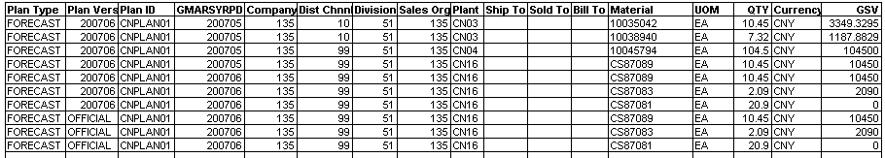
Example of Forecast File (shown in Excel):
Note: even though this file shows the data in an Excel spreadsheet, the file must be in TAB delimited format. This is due to a limitation on the format expected by BW.

Outputs
The output of this process will be a Forecast in both Quantity and GSV in the BW Sales Forecast reporting cube.

Loading of forecast data file to BW

Introduction
This process will be responsible for converting the forecast data file quantity values into GSV values.

Inputs
The input into this process the Quantity forecast data (as defined under Extract of GSV/Qty Forecast from China Forecast Database System 13) and loaded into BW using the existing Web based Sales Forecast data file loading process.

Processing
The merged data file is loaded into BW using an existing Web Page data loading process (as defined under BW Web Page for Loading Sales Forecast Data 18).

Outputs
The output of this process will be a Forecast in both Quantity and GSV in the BW Sales Forecast reporting cube.

Interface Requirements
In summary, the following interfaces will be required to deliver the functionality described in this document:

User Interfaces

China Forecast Database System Forecast Extract Screen
<<< TO BE CONFIRMED BY LINDEN >>>
This screen (Web Page??) is responsible to allowing the user to define and extract a Forecast Data file from the China Forecast Database system ready for loading into BW.

BW Web Page for Loading Sales Forecast Data
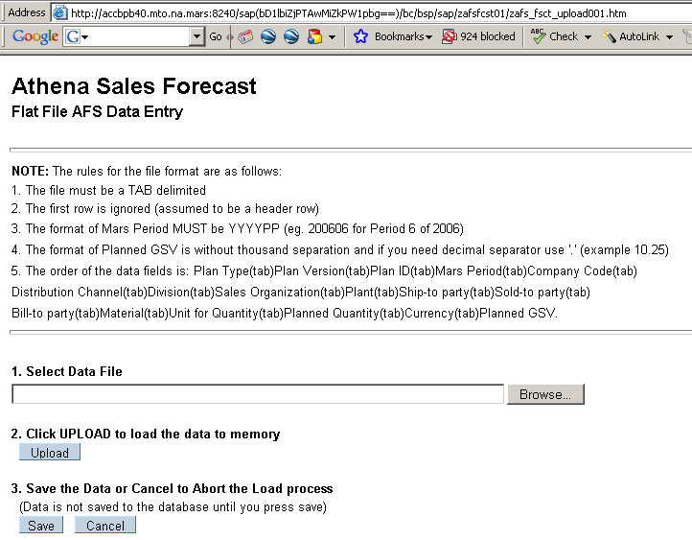
Once the forecast data files are merged, they will be loaded into BW using an existing Web based data loading screen as follows:

System Interfaces
The following system interfaces will be required for this functionality:

Apollo Demand to Apollo Supply
This interface is defined under Apollo Supply Manipulated Domestic Quantity Forecast 6

Atlas Pricing data load into China Forecast Database System
This interface is defined under Loading of Pricing data from Atlas to China Forecast Database System 8.

